***ultrasonic sensor interface-obstacle detector and distance measurement.***

Circuit Diagram:

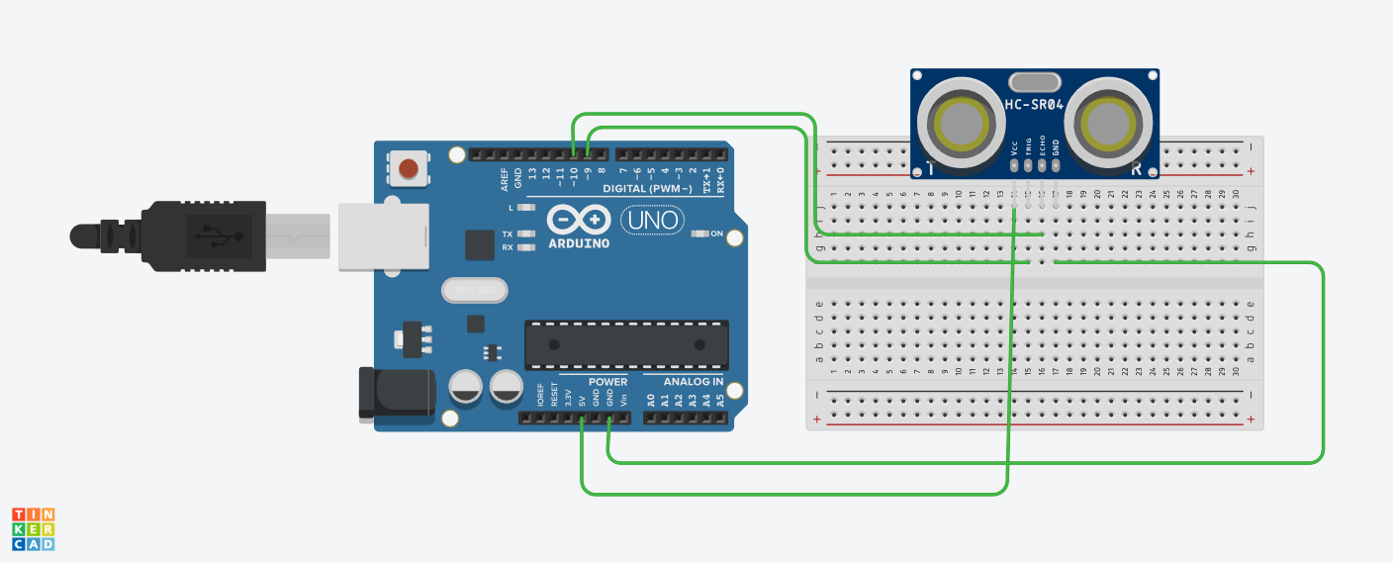

**Theory:**

Concepts Used:

1. Using of ultra sonic sensor.
2. Coding Arduino.

**Learning & Observations**:

Learned the use of ultra sonic sensor.Understood the working of Arduino.

There are many uses of ultra sonic sensor.

**Problems & Troubleshooting**

Unknowingly the terminal of ultra sonic sensor is connected wrongly with Arduino.

Understood the mistake and learned the connections of sensor.

**Precautions**

1. Check the sensor and Arduino are working properly.
2. Declare pins used .
3. Connect positive terminal of elements to the digital output and negative terminal to the ground.
4. Ultrasonic sensor should be connected properly.

**Learning Outcomes**

Learned connections of ultra sonic sensor and it was really fun. Understood the uses of ultra sonic sensor. Things I learned will be very useful.